CLIENT SERVER APPLICATION WITHC#.NET(WORK-LOG)

**INSTALLING SOFTWARE**

Firstly, I have downloaded latest version of visual studio 2019, using link <https://visualstudio.microsoft.com/downloads/>

Soon after downloading, It will show to install in the next window , while installing we need to choose the option .Net desktop development where we can build WPF, windows forms and console applications using c#, visual basic, and F#. Now click on install.

 Visual Studio will download the relevant files based on the option we chose on previous step. Once the download is done, you will be asked to reboot the PC.

Now the visual studio is ready to use.

**CREATING THE PROJECT**

Choosing the option CREATE PROJECT we can navigate   to File menu to create new C# applications.

The first step involves the creation of a new project in Visual Studio. For that, once the Visual Studio is launched, you need to choose the menu option NEW 🡪 PROJECT. If you have created any projects before then we can open them while choosing the option OPEN PROJECTS.

After choosing the option CREATE PROJECTS, we need to choose the platform where we want to create the project. Choose WINDOWS FORM APP(.NET FRAMEWORK). Soon we need to give the name of the project.

We will finally launch on the window where we will create the forms. There we see the TOOLBOX on left-side of the window, where we can find all the tools required to create the form like TEXTFIELD, BUTTON, LABLE ….etc.

Using those tools we will create the forms.

**PROJECT**

Here I have created the client form using the tools provided and for the server form I have used Hercules setup .

Hercules is an extension we can use for the connection of client server communication instead of creating the forms. Here I have used Hercules_3-2-8.extension.

Here is the CODE for the client form and required properties:

I have uploaded the code directly in the work load.

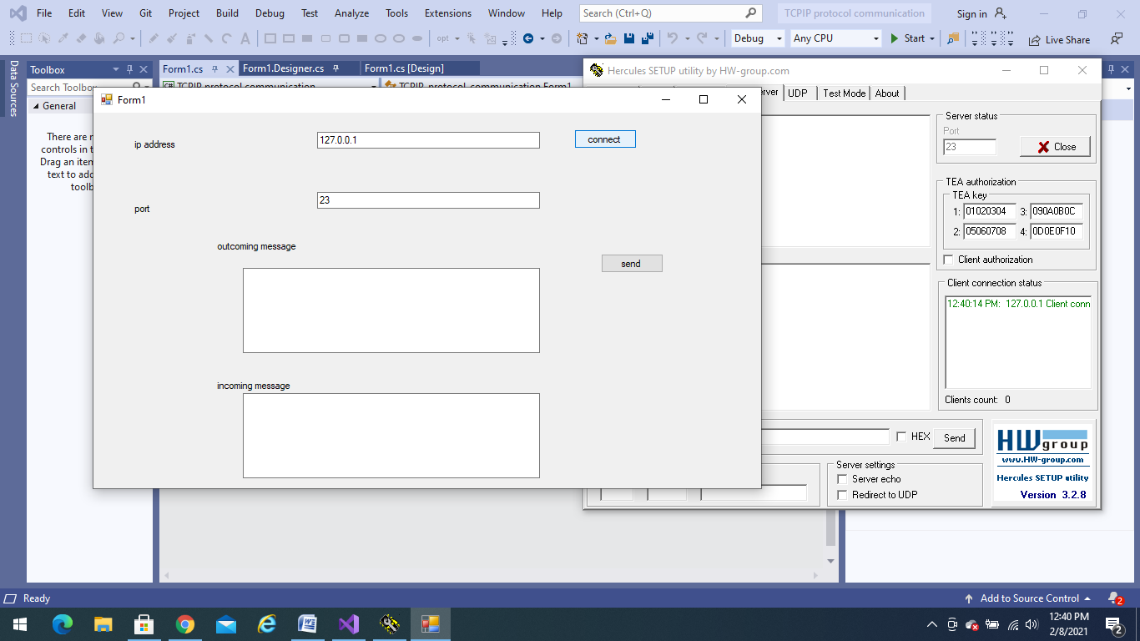

This picture shows the client connection with the server, after performing certain steps the connection is established successfully.

Now lets check the data sending and receiving.

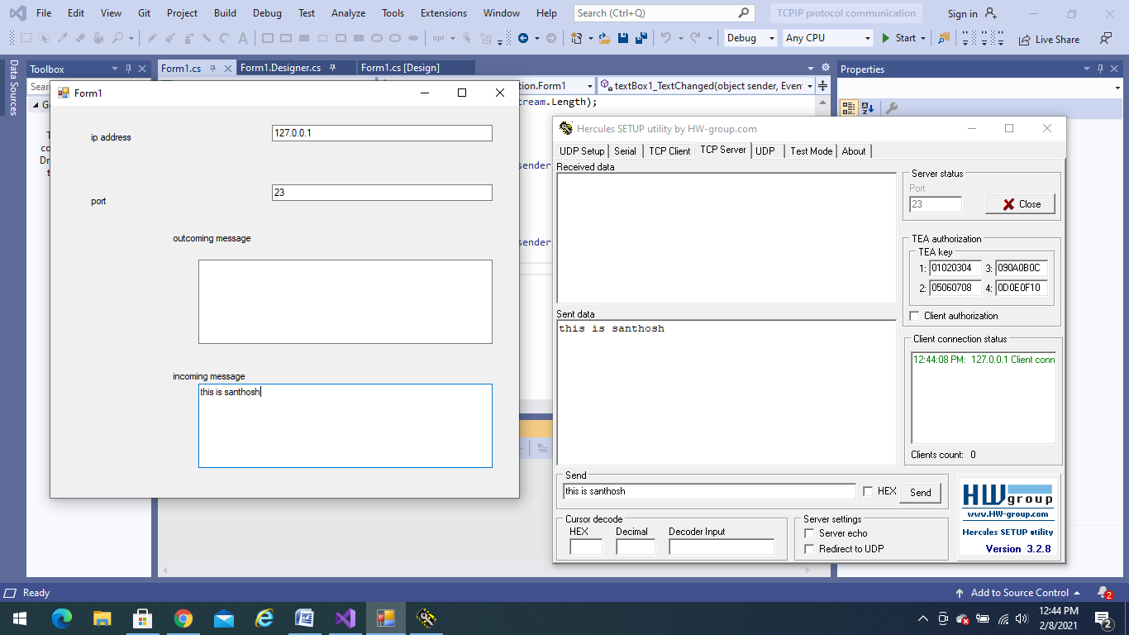

Here after the connection is established with the port address, the data from server is sent to the connected client.

Lets check whether the data is sending from the client to server:

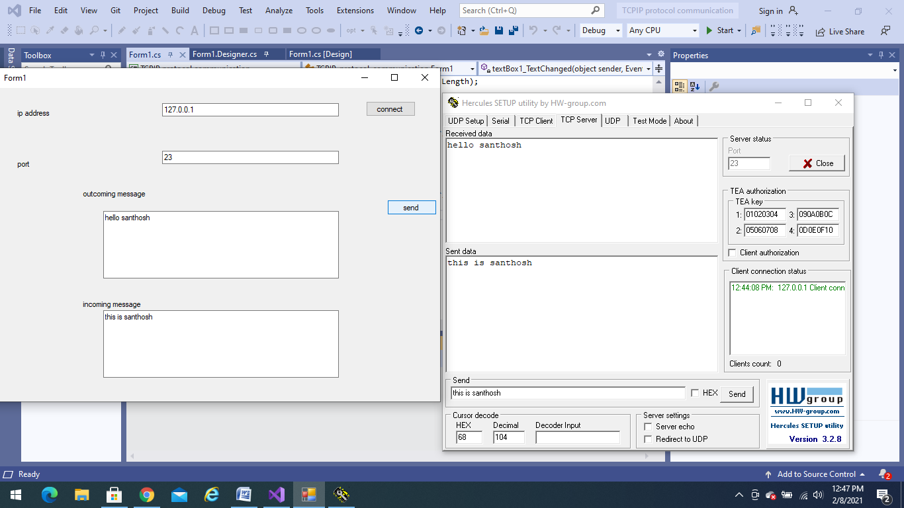

Successfully the communication is established between the client and server.

**LEARNING OUTCOMES:**

While performing this task I came across many new options like creating installation of visual studio, difference between TCP/IP and UDP, creation of forms, how to establish the communication between the client server and also about Hercules extension.

**CONCLUSION:**

Finally, I have taken approximately THREE HOURS to complete the whole project, and successfully established the communication.